A

Mini Project Report

On

“YouTube Channel Branding”

Submitted to

CHHATTISGARH SWAMI VIVEKANAND TECHNICAL UNIVERSITY
BHILAI

in partial fulfillment of the requirement of for the award of degree

Of

Bachelors of Technology

In
COMPUTER SCIENCE AND ENGINEERING
By
Your name


DEPARTMENT OF COMPUTER SCIENCE AND ENGINEERING
SHRI SHANKARACHARYA TECHNICAL CAMPU,
JUNWANI, BHILAI(C.G.)

SESSION 2021-2022

CERTIFICATE

This is to certify that the thesis report of the project submitted is an outcome of the project entitled “Mini Project” carried out by Sumit Kumar bearing Roll no. 30 carried out under my guidance and supervision for the award of Degree in B.Tech in Computer Science and Engineering of Chhattisgarh Swami Vivekanand Technical university, Bhilai(C.G.),India.
To the best of my knowledge the report.

(1)Embodies the work of the candidates himself.
(2)Fulfills the requirements of the ordinance relating to the B.Tech Degree of the University.And ,
(3)Is up to the desired standard for the purpose of which is submitted.

(Signature of the Class Teacher)
xxxx
Professor
Computer Science & Egineering Department
Shri ShankaraCharya Technical Campus
Junwani,Bhilai(C.G.)

The project work as mentioned above is hereby being recommended and forwarded for examination and evaluation.

(Signature of Head of Department with seal)

ACKNOWLEDGEMENT

In the accomplishment of this project successfully, many people have best owned upon me their blessing and the heart pledged support, this time I am utilizing to thank all the people who have been concerned with the project.

Primarily I would thank God for being able to complete this project with success .Then I would like to thank my principal Mr. J Prasad and Computer science teacher Miss. PriyankaKulshrestha whose valuable guidance has been the ones that helped me patch this project and make it full proof success their suggestions and their instructions has served as the major contributor towards the completion of this project.

Then I would like to thank my parents and friends who have helped me with their valuable suggestions and guidance has been helpful in various phases of the completion of this project.

(Signature of student)

Abstract

The Internet has become a part of our daily routine now everyone having a internet connection can utilize the resources present over the internet.

New information is posted every fraction of time over the web. This makes the web a really giant hub of information. We can also utilize the same web to spread our work and engage more people to utilize it. The best way to achieve the same is to design a website which can navigate the users to their required destinations without bothering them to identify the valid addresses in a more interactive way.

This can increase the user engagement on your work providing you with more opportunities to grow and showcase your work.

Introduction
The main objective of the
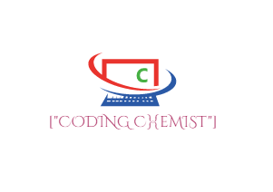
Web development Project
On YouTube Channel Branding
is to manage the details about the Courses, content, notes and managing the user interaction with the channel through other means of connections.

It manage all information about the activities that the channel is currently undergoing to keep the viewers updated .The project is totally built at administrative end and thus only the administrator is guaranteed the access .The purpose of the project is to build an application program to reduce the manual work for managing the notes, updates, notification and users queries at one place without making them visit tons of different urls.
This is basically concern with the branding and recognition of the channel among the viewers, The need of this website is that to provide the users a different platform to interact with the channel so as to increase their interaction as well as interest into the content .

Tools and Technology used

1) HTML
2) CSS
3) JavaScript

Working With Project

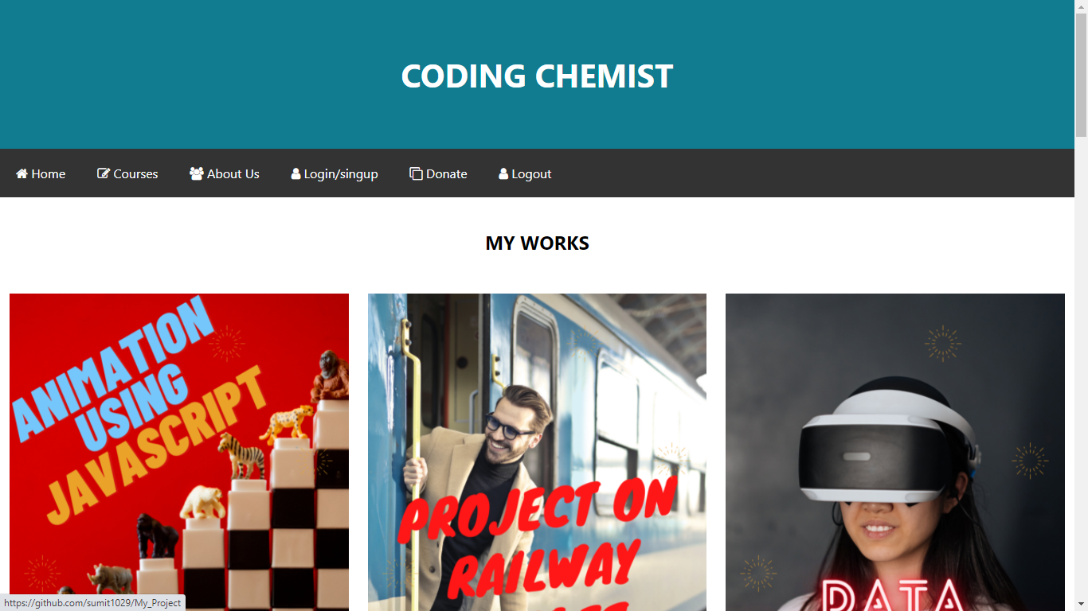

This is the first home page of the website which contains the basic details that need to be available to the viewers for the better engagement and interaction with the site.
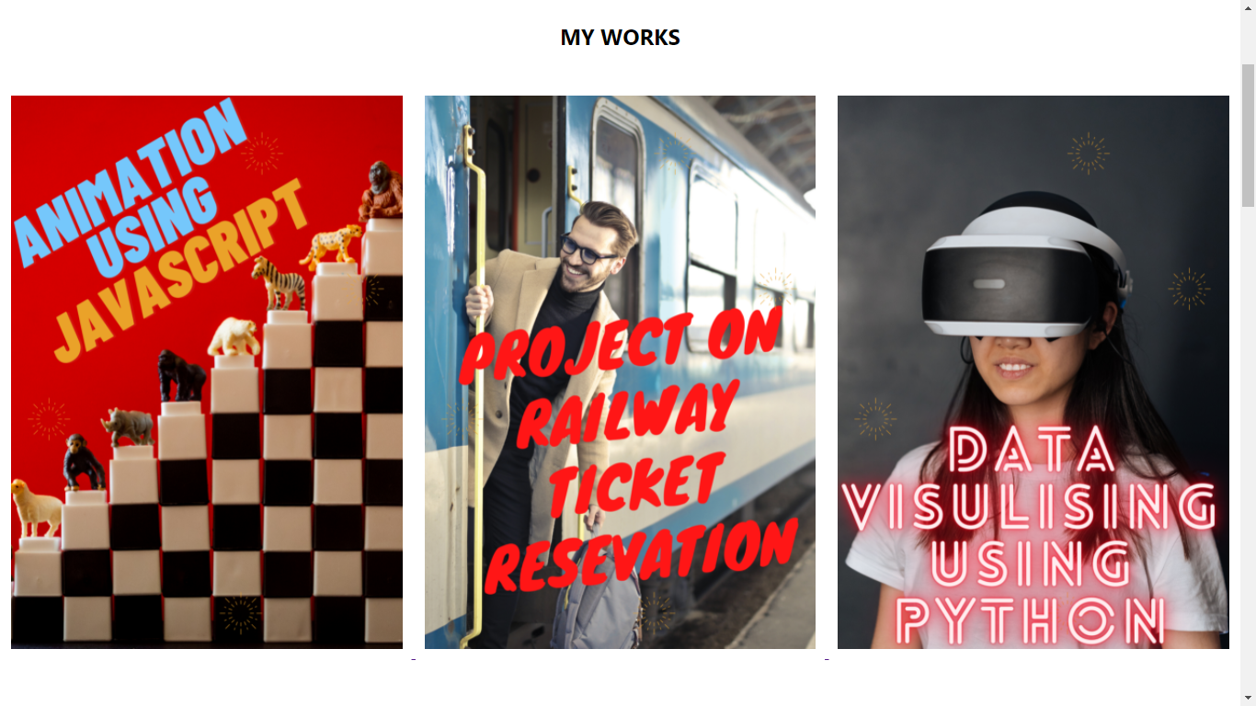

The section of the home page titled “My Works” is the collection of my projects in the field of coding which were showcased with the help of appropriate thumbnails and linked to the github directory where the projects are saved.

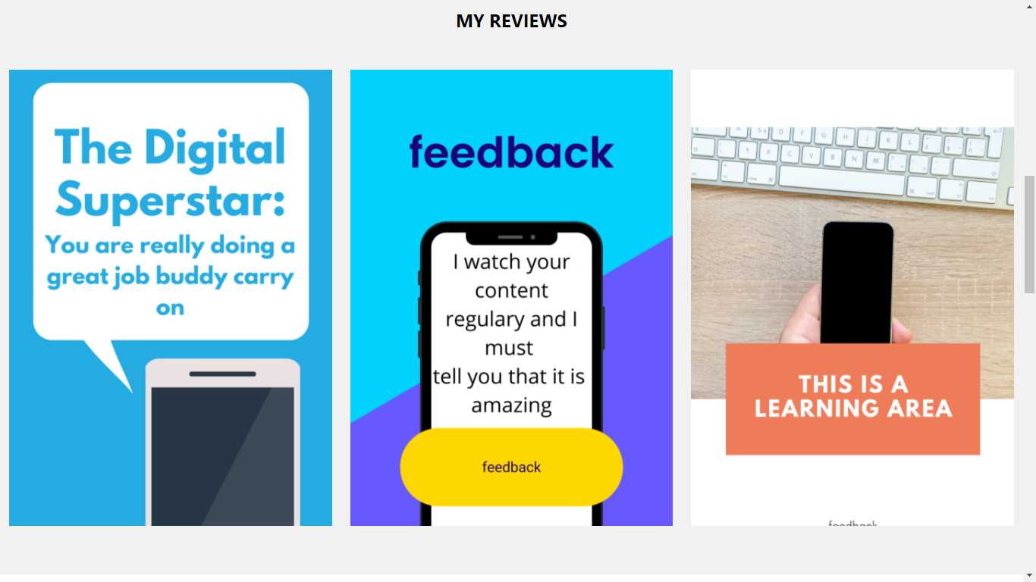

This section titled my reviews contains the reviews obtained by the views so far on my content.

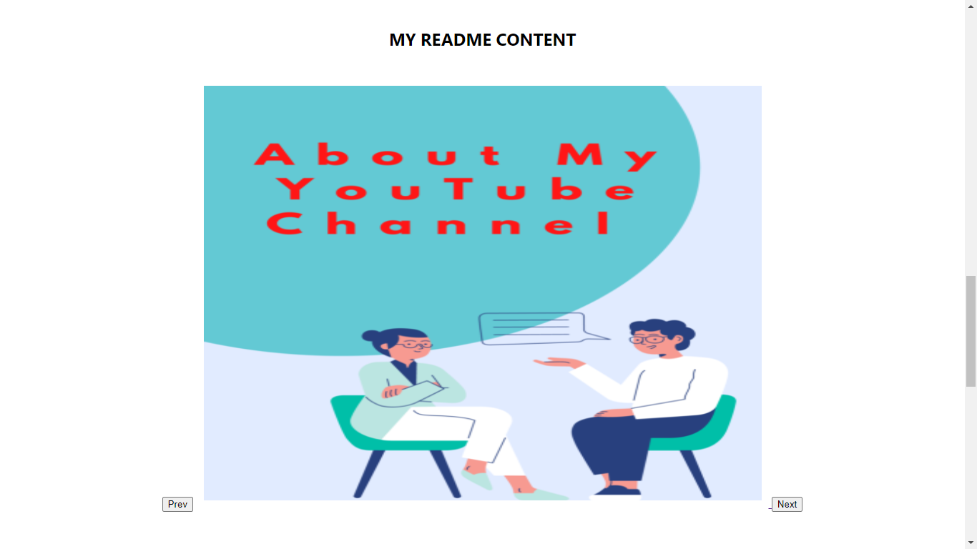

This section contains my readme information to be available for the viewers. This section contains the content in the form of a slider with the help of JavaScript.

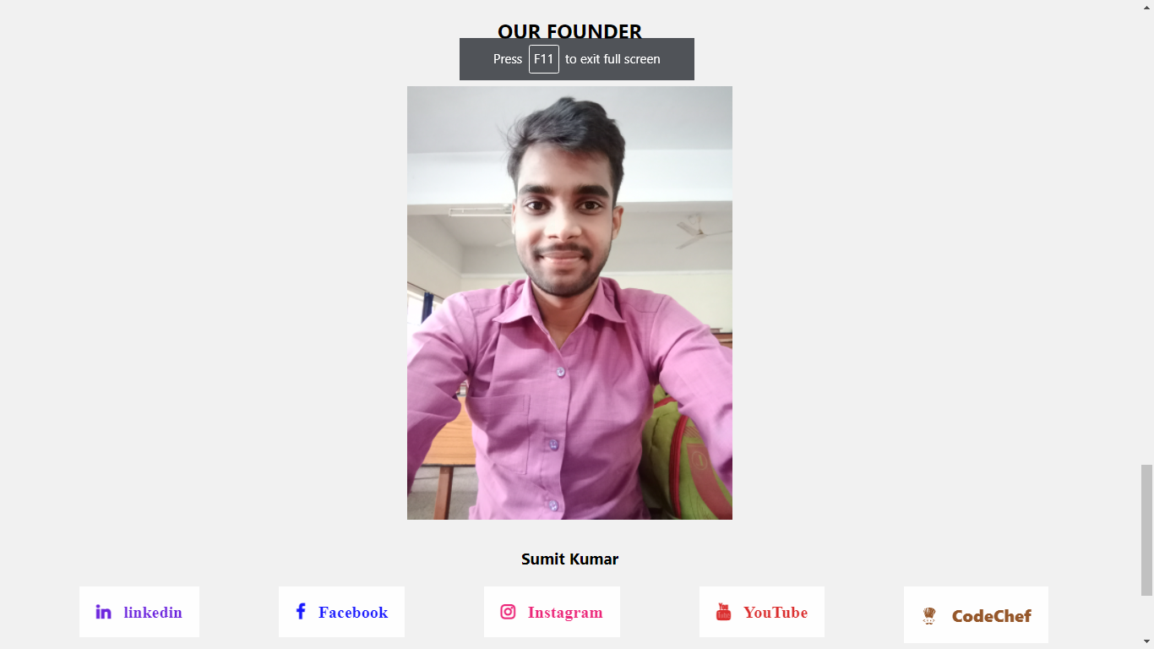

This section contains the information about the channel founder along with the various social media links.

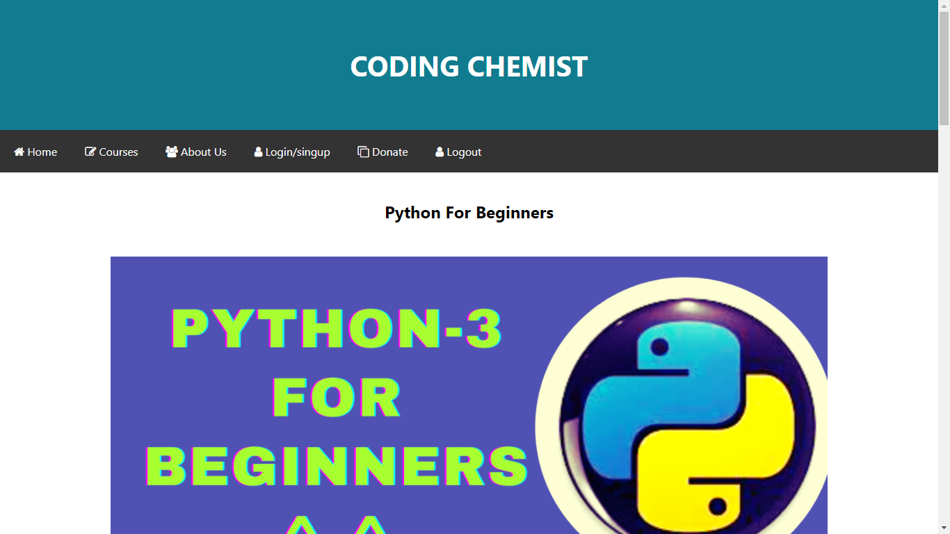

The courses page to make the users know about the various ongoing and upcoming courses on the channel.

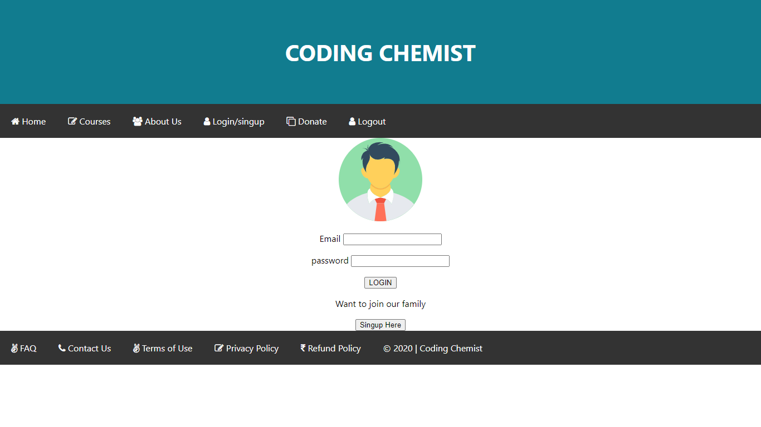

Login page for the registered users.

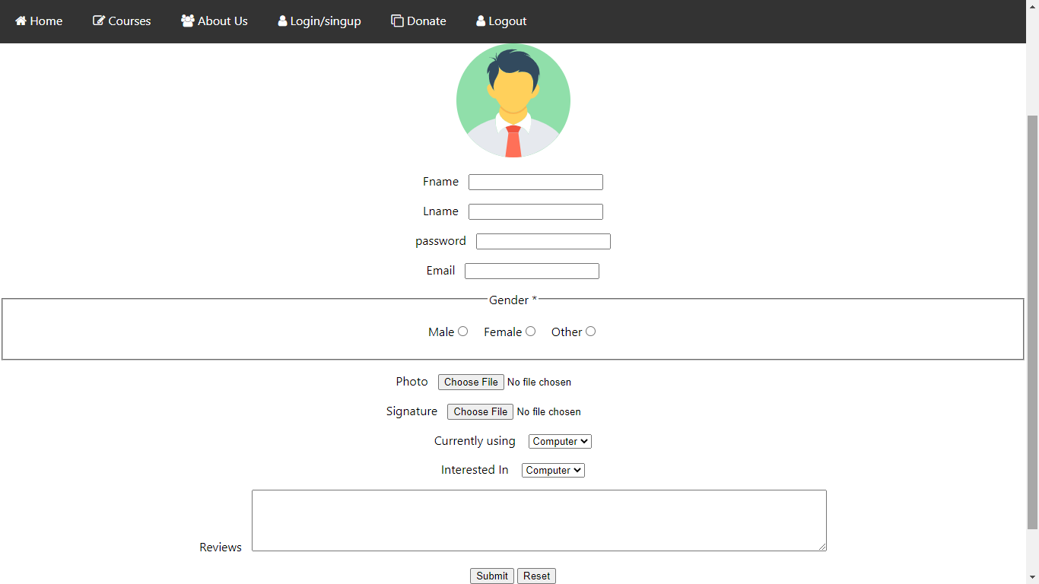

Singup page for the new users visiting the website.

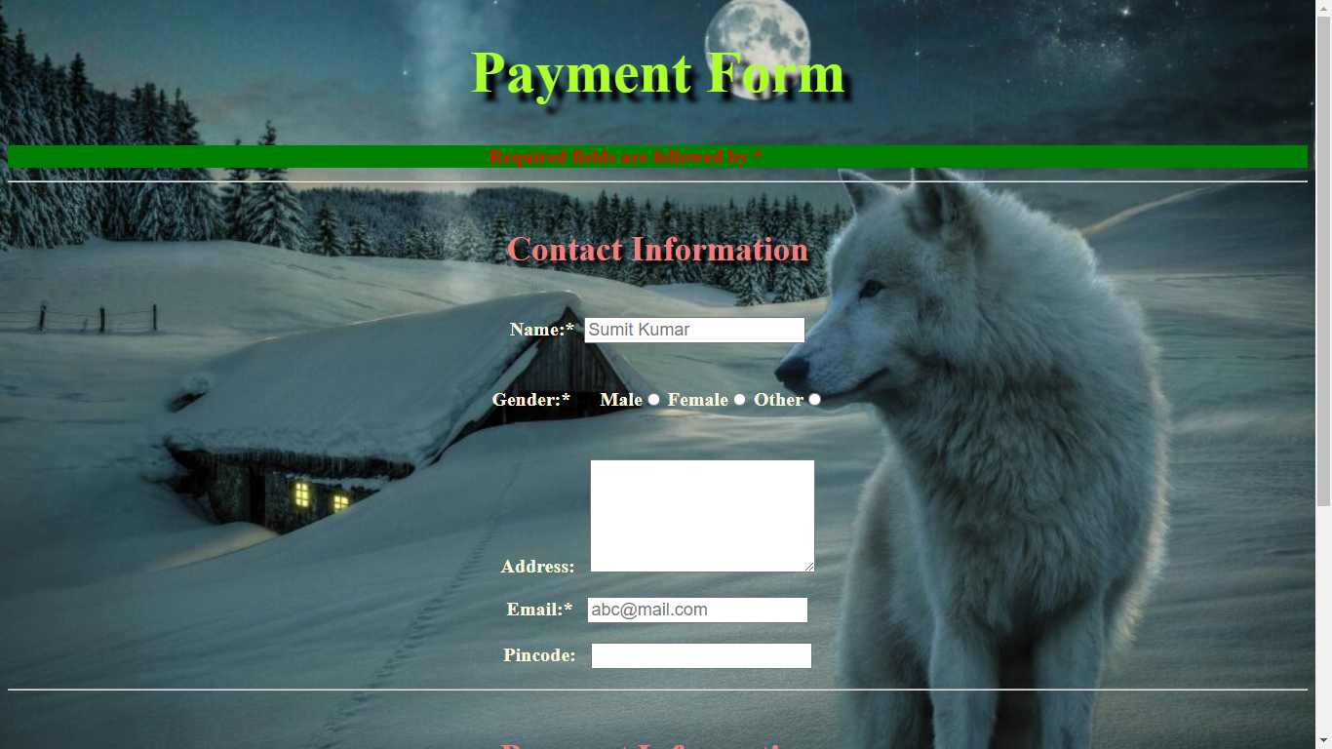

This is the payment page for those visitors who are interested to support the channel with their contributions.

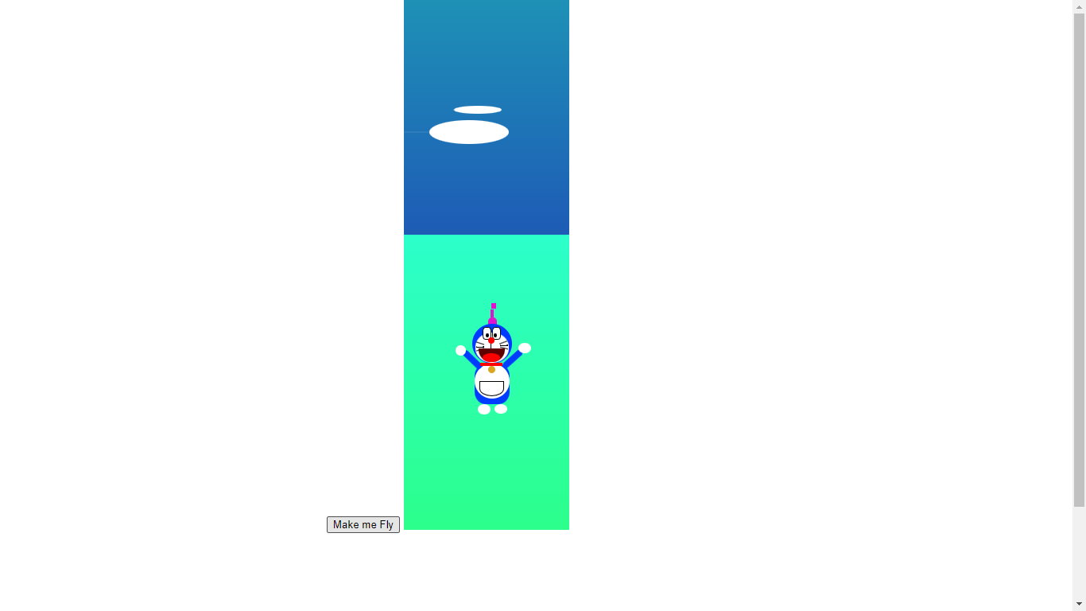

The final window when a user clicks the logout page. Designed to increase the chances of the user to revisit this site.
CONCLUSION AND SCOPE FOR FUTURE WORK

This kind of channel branding sites can play a really important role in the reach and recognition of the content created and posted by any individual or group through the medium of YouTube.

Since these sites are mainly focused on the content and creators the development does not tends to get really complex. Any viewers can easily be directed to these sites and could interact really well on their own. This makes the subscribers to get connected with the channel as well as the creator on other different platforms too.
The approach to publish the part of the content over the web with the means of a website of your own creates an opportunity to get recognized at a higher rate than usual. Starting with a basic design of the website and optimizing it in the future according the needs when we get enough resources and reach would be the main objective of this site along with the retention of the viewers.

